IRT Class Assignment

Run an IRT analysis on the data from an Educational Psychology Test on **questions 2-5**.

1. Calculate the summary statistics on those questions.
   1. Looking at the items, what might you expect? Do some of them seem easier than others?
      1. They are all pretty easy.

> summary(data)

V2 V3 V4 V5

Min. :0.0 Min. :0.0000 Min. :0.0000 Min. :0.0000

1st Qu.:0.0 1st Qu.:1.0000 1st Qu.:0.2500 1st Qu.:1.0000

Median :1.0 Median :1.0000 Median :1.0000 Median :1.0000

Mean :0.7 Mean :0.9333 Mean :0.7333 Mean :0.8667

3rd Qu.:1.0 3rd Qu.:1.0000 3rd Qu.:1.0000 3rd Qu.:1.0000

Max. :1.0 Max. :1.0000 Max. :1.0000 Max. :1.0000

1. Calculate the models.
   1. Run a 2PL model.
   2. Run a 3PL model.
2. Include the following:
   1. ICCs for 2 and 3PL.
   2. TIF for 2 and 3PL

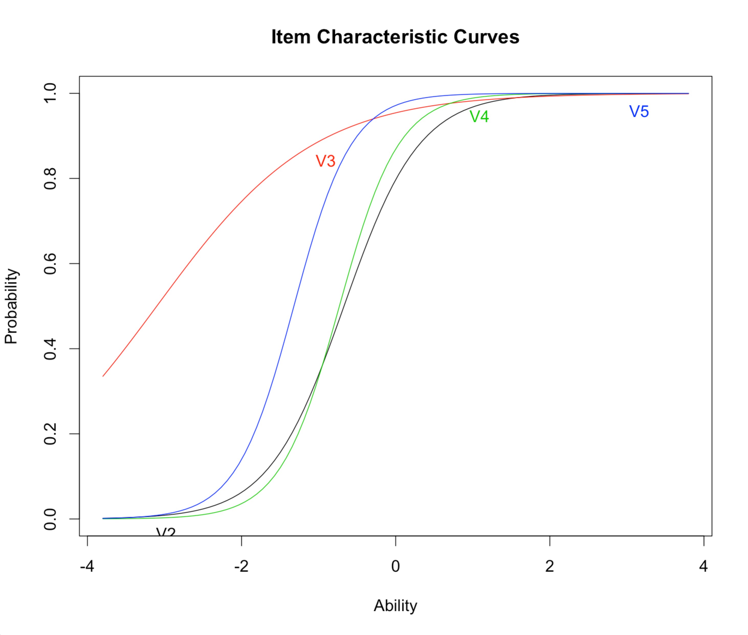

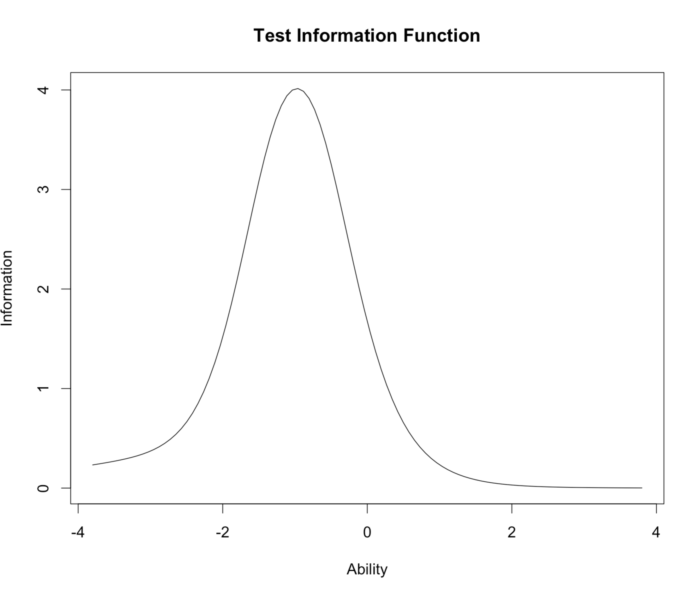

1. Which model is better?
   1. The two pl model with the lower AIC value.

Likelihood Ratio Table

AIC BIC log.Lik LRT df p.value

model 113.48 124.68 -48.74

model2 121.48 138.29 -48.74 0 4 1

* 1. Is the guessing parameter necessary? Nope

1. Interpret your findings:
   1. Items:

Dffclt Dscrmn

V2 -0.6709885 2.0380646

V3 -3.1003782 0.9793271

V4 -0.7307125 2.5908115

V5 -1.3209210 2.6748421

* + 1. Which questions are good items for discrimination?
       1. Pretty much all of them if you are using a > 1
    2. Which questions measure below average ability (i.e. they are easy)?
       1. All of them!
    3. Which questions measure above average ability (i.e. they are hard)?
       1. None of them, no b > 0.
  1. Factor Scores:
     1. Do the patterns of factor scores match what would be expected for the data?
        1. Yes, we see observed and expected are roughly equal.
     2. Do those patterns fit the model? Which patterns are inconsistent?
        1. A couple are inconsistent but are only measured by one pattern of scores.
     3. Do the items fit the model?
        1. The p values are significant, but the good a and b values indicate they might be worthwhile, especially with more participants measured.